

Web Technologies I

# TERM PROJECT

**INSTRUCTOR: Javeria Aamir**

**CLASS:** Winter 2021 (CSD 1113_1)

Date : 02-04-2021

Prepared by:

Yamini Rathod C0796390

Srikanth Ajith Kumar Yarram C0793406

Payal Desai C0793424

**“Royal Travel Club”**

TERM PROJECT CODE VALIDATION

|  |
| --- |
| Home Page |

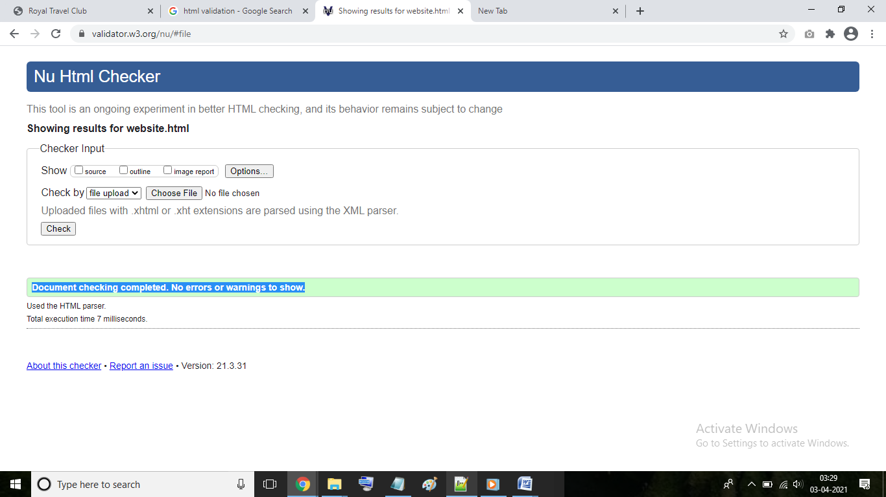

|  |
| --- |
| Explore Places Page |

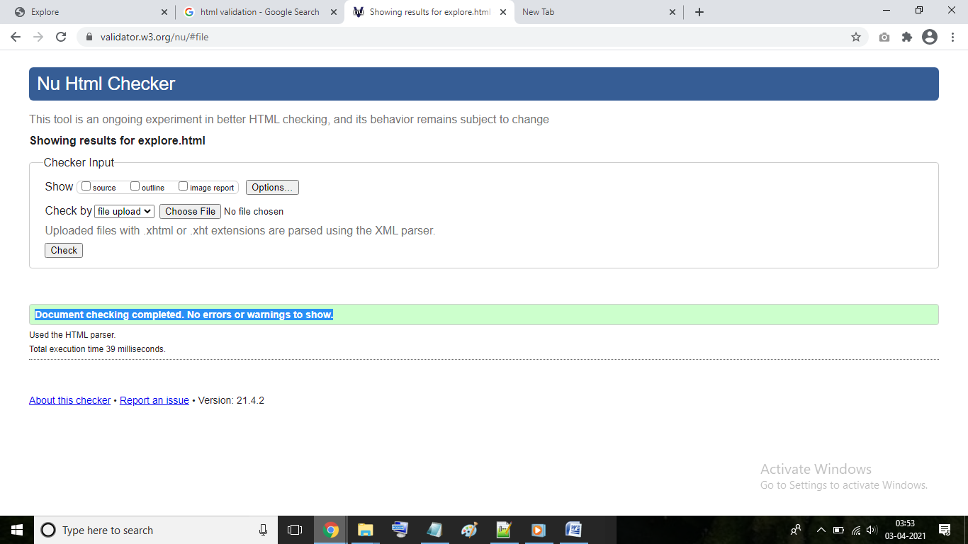

|  |
| --- |
| Packages Page |

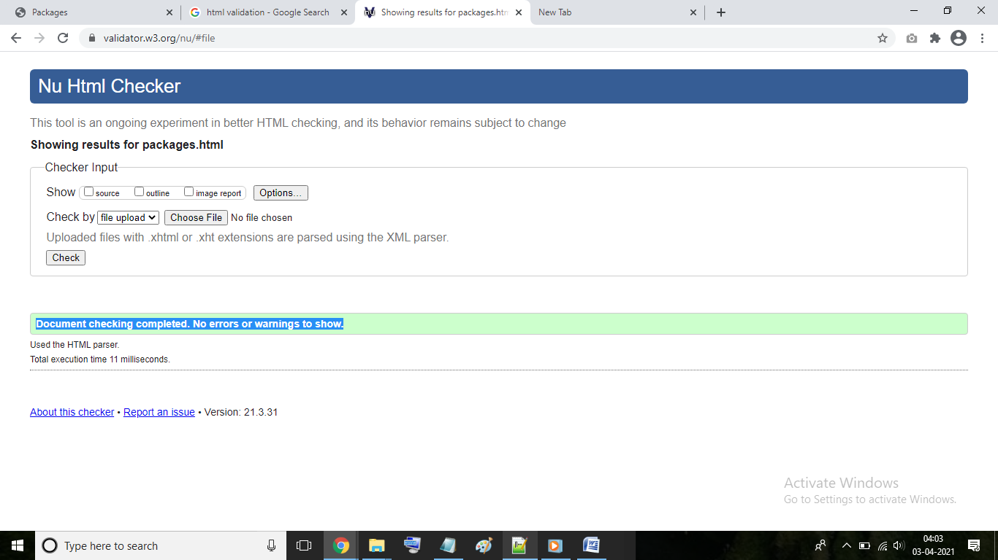

|  |
| --- |
| Offers Page |

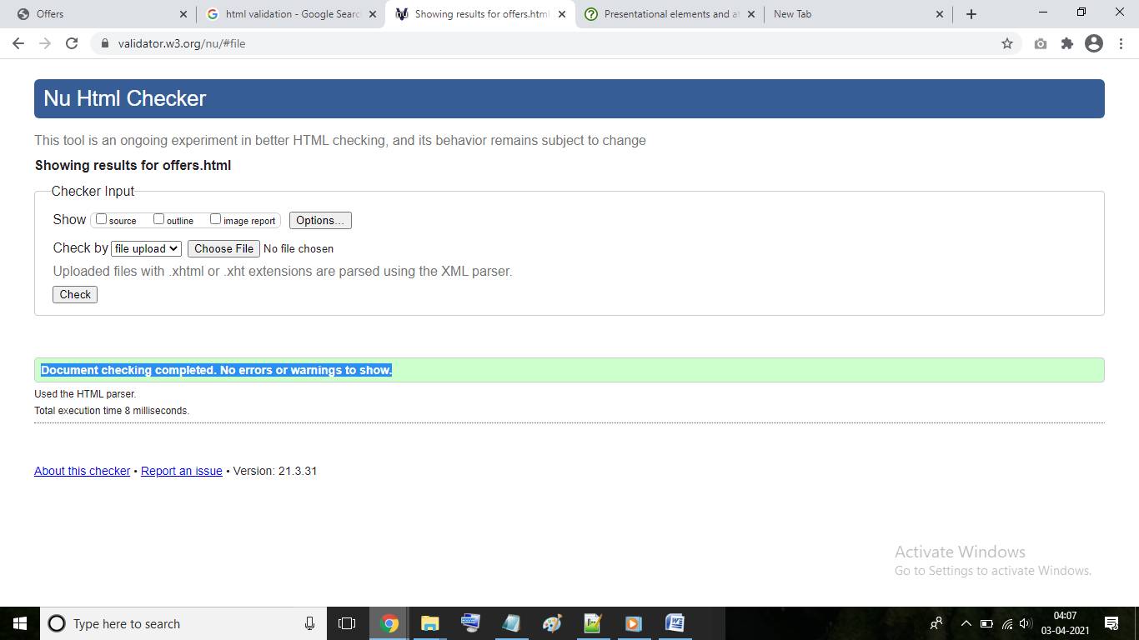

|  |
| --- |
| Reviews Page |

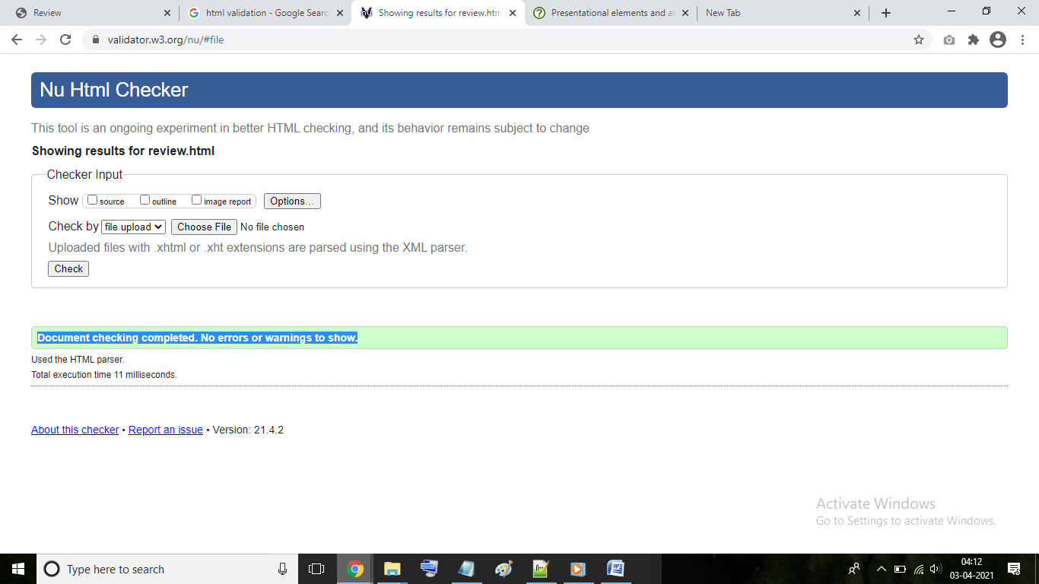

|  |
| --- |
| FAQ Page |

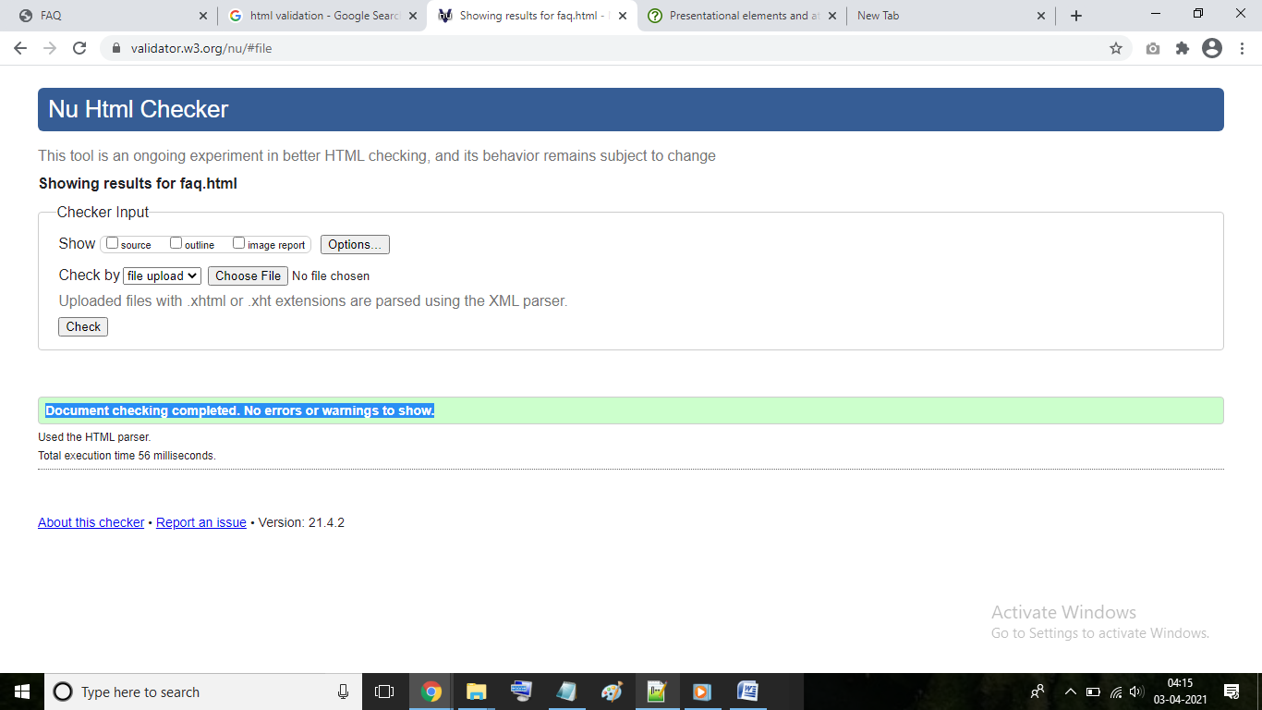

|  |
| --- |
| About Us Page |

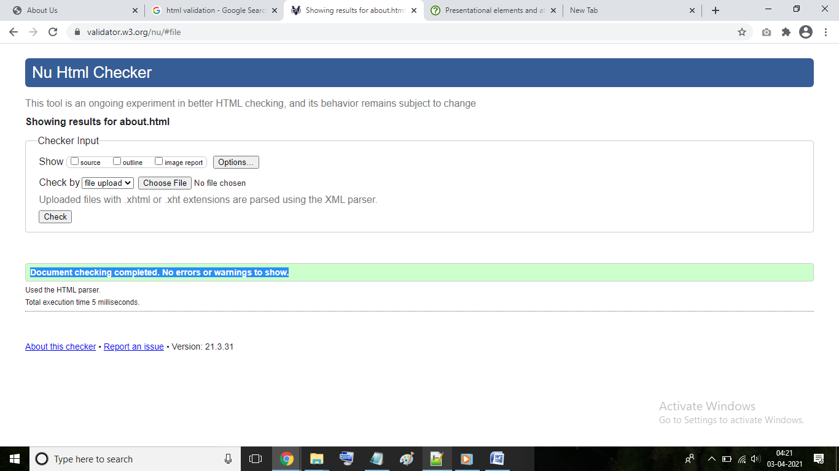

|  |
| --- |
| Contact Us Page |

